Book price ~~500RS~~ 200RS

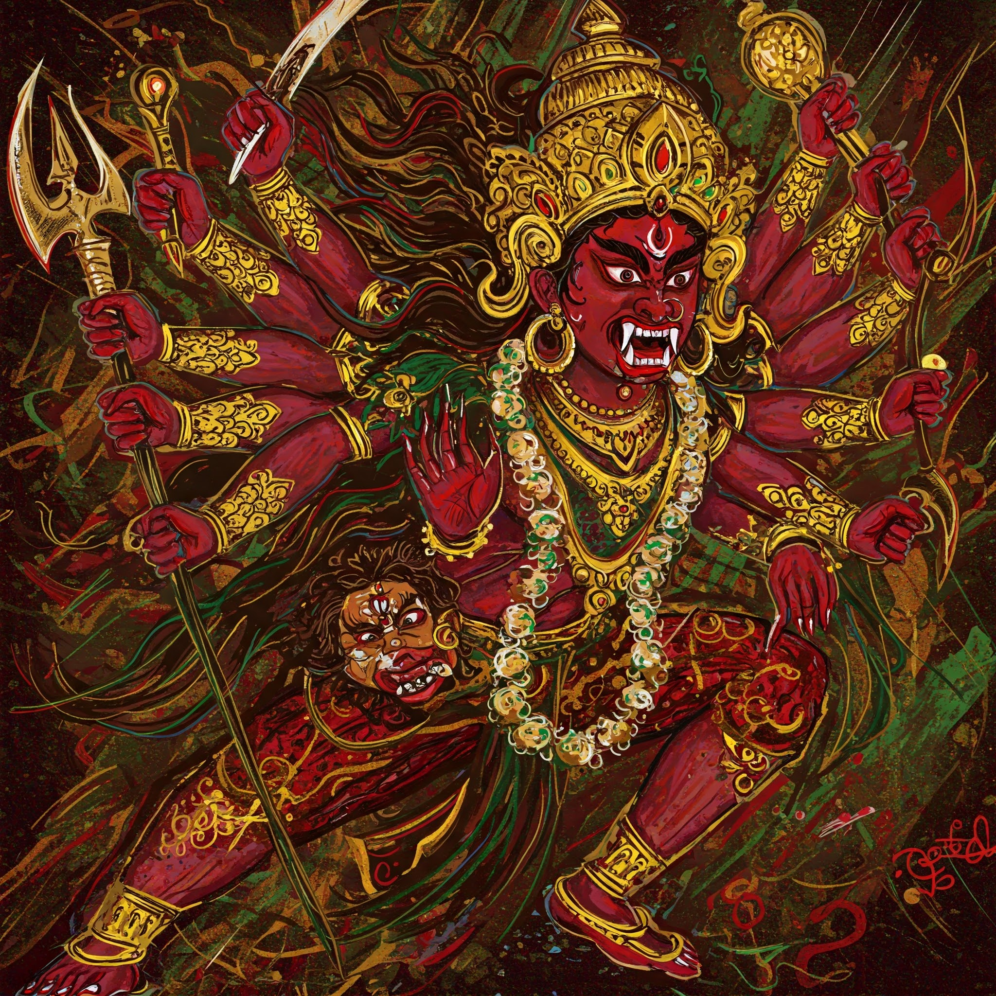Beneath a sky streaked with wisps of violet and gold, an old bicycle rested against a crumbling brick wall, its tires half-buried in overgrown grass. A cat with mismatched eyes prowled along the edge of the sidewalk, pausing occasionally to peer into the shadows. The wind whispered through the trees, carrying the scent of rain and something faintly sweet—perhaps jasmine, or something older and less familiar. A radio crackled from a nearby window, playing a tune from another era, long before smartphones or silent scrolling. Somewhere nearby, laughter echoed briefly, as if caught in a loop of memory. The streetlamp flickered uncertainly, casting long, shifting shadows across the cobblestones. A single glove lay forgotten

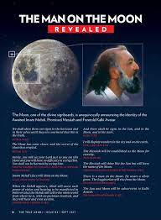gutter, damp and turning inside out. No one seemed to notice. The world held its breath, caught between the promise of a storm and the hush of dusk. Time moved oddly here—not slow, but sideways—like pages turning in a book with no beginning or end.csds Somewhere, a dog barked once, then felldddd dddsilent. In that moment, nothing happened, and yet everything felt poised to begin. The ordinary wrapped itself in mystery, and even the smallest detail seemed to shimmer with unseen significance.

* **GODDESS KALI**
* **MOON GOD**
* **STAR GOD**

1. ***CREATED IMAGE FROM CHATGPT***
2. ***CREATED IMAGE FROM GEMINI***